The first in a long line: an investigation into the anxiogenic effects of alcohol abuse

Clare Bradley
300410614
Word Count: 7032 (old rule)
PSYC489 Research Project
Victoria University of Wellington

Acknowledgements:
I would like to sincerely thank Bart Ellenbroek, Sahir Hussain, Henry Chafee, Kate Witt, Katie Blackburne & Larissa Rocha
Abstract:
We conducted an experiment to investigate whether long term alcohol abuse exacerbates anxiety. Based on previous literature on the topic, we predicted that animals chronically exposed to alcohol would be higher in measures of anxiety than animals not exposed. Using the Intermittent-Access Two Bottle Choice paradigm, we exposed 20 rats to 20% ethanol over the course of eight weeks. We then tested their anxiety using the Affective Disorders Test, which combined anticipatory measures with anxiety measures. The test found no difference in anticipation or anxious behaviours between the animals exposed to alcohol and the controls. However, both the Drinking rats and the controls showed much less anxiety than previously seen in the lab, and were highly excitable, which likely influenced these results. We suspect housing the animals individually for higher accuracy in ethanol consumption day contributed to this, and highly recommend repeating this experiment using paired animal housing.

Introduction:
New Zealanders have a complicated relationship with alcohol use. We drink socially, as a rule, but this stretches across an impressive number of situations. Dates, parties, sporting events, celebrations, and spending time with friends are all acceptable occasions in which to drink. Alcohol is paired with any scene from the end of the workday to wedding toasts, and it can consequently become very difficult to avoid. Considering this, it is unsurprising that many New Zealanders struggle with alcohol addiction. Across 2019/2020 over 20% of the New Zealand population showed hazardous patterns of alcohol consumption, and men were over twice as likely to show those patterns than women (ActionPoint, 2020). Those living in rural areas are 1.3 times more likely to engage in hazardous drinking than those in urban areas, despite having fewer people that drank (Ministry of Health, 2018). Roughly 33% of those aged 18-24 in New Zealand drank hazardously in 2015-2016, and this cohort of young people were the most likely in the country to have more than one binge-drinking episode (more than six drinks on one occasion) a week (Te Hiringa Hauora/Health Promotion Agency, 2017). All this points to an obvious conclusion: we’re drinking dangerously. But what are the consequences of this danger?
In the short term, alcohol produces several physiological responses that detract from the pleasure of drinking. These include blurred vision, dehydration, irregular heartbeat, a loss of coordination, and slurred speech, to name a few of the most notorious (Te Hiringa Hauroa/Health Promotion Agency, 2021). And this excludes the countless possible injuries one could sustain while intoxicated that result from the list above. In 2020, the New Zealand Transport Agency linked alcohol consumption to 262 serious injuries and 90 deaths resulting from car crashes (2021).
In the long term, the consequences of chronic alcohol consumption become more insidious. Greater alcohol consumption has been found to predict liver failure, stroke, heart disease, high blood pressure, pancreatitis, and perhaps even several cancers (National Institute of Alcohol Abuse and Alcoholism, 2021). Alcohol has also been associated with a long list of medical complications, such as a weakening of the immune system, osteoporosis, reduced fertility in men and women, and weight gain (Te Hiringa Hauroa/Health Promotion Agency, 2021). Alcoholism is comorbid with a myriad of psychological disorders, including depression (Merikangas & Gelernter, 1990), bipolar (Frye & Salloum, 2006), and most notably in the context of this study, anxiety (Chambless et al, 1987, Barchiesi, 2021, Pirkola et al, 2005).
The acute effect of alcohol on anxiety is reductive; alcohol diminishes immediate anxiety and is often used in social situations to relax otherwise anxious individuals (Keough, 2016). We use the colloquial phrase ‘liquid courage’ to describe drinking alcohol to stop us worrying about an upcoming task. It should be no surprise then that high social anxiety has been identified as a predictor of solitary pre-drinking (drinking before heading to a social event involving alcohol) (Keough, 2016). Even as quickly as the next day, however, alcohol consumption has the opposite long-term effect. Anxiety is typically increased as alcohol leaves the body during hangovers (Karadayian et al, 2013), amongst a host of other unpleasant sensations. Once the alcohol is completely flushed from your system, the affective change returns to baseline with time. But people that drink alcohol hazardously do not likely wait that long before they drink again. So, we must investigate what repeated, intense exposure to alcohol produces in the form of anxiety.
Previous research has both identified alcohol abuse as a predictor of anxiety disorders and anxiety disorders as a predictor of alcohol abuse (Kushner et al, 2000, Keough, 2016), but little has been done to untangle this relationship. This is, in partiality, because investigating a causal direction in such a relationship is nearly impossible to do in humans. We cannot control for confounding variables that impact anxiety or alcohol use (and there are many). In cases such as this, animal models provide an excellent starting point for teasing apart causality. Rats have been used to study alcoholism for decades, and we now have several models that accurately mimic human behaviours of addiction, such as craving, relapse, and withdrawal (Spanagel, 2000). Previous research using these models has found evidence to suggest that prenatal exposure to alcohol increases anxious and depressive behaviours in offspring in Sprague-Dawley rats (Brocado et al, 2012). Additionally, Gilpin et al found that binge drinking in adolescent rats reduced anxiety in the Elevated Plus Maze (EPM), but increased it during adulthood (2012). However, there have been several faults identified with the EPM since the publishing of this paper. The EPM has a strict one-trial tolerance, within which anxiety measures are confounded by the rats’ exploratory behaviour in novel environment. There is also the issue of the ambiguous central area, which is uncovered, suggesting an anxiogenic property, yet the animals are at no risk of falling and can easily run into the covered arms, which perhaps nulls this effect.
This brings us to the context of the current study. The research above strongly suggests that chronic alcohol consumption contributes significantly to the onset of anxiety disorders, or perhaps greater trait anxiety as a whole. However, it is still unclear whether this is the case in of itself, or whether those who are already high in anxiety are predisposed to drinking alcohol for its acute anxiolytic effects. Of course, this is a false dichotomy; the answer is likely somewhere between these two positions. But this is not to say that examining the causal relationship between alcohol and anxiety is pointless: we stand to gain a greater understanding of binge-drinking and anxiety by first confirming that, as stated above, alcohol abuse alone predicts greater anxiety. Using animals models of alcoholism, we aimed to replicate the findings of Brocardo et al and Gilpin at al, while incorporating novel measures of anxiety to account for the flaws in the EPM in the form of the Affective Disorders Test. This test eliminates the one-trial tolerance of the EPM by incorporating a palatable food reward into the procedure, which encourages the animals to explore further than they would on the first trial. This is coupled with an anticipatory factor to ensure that the animals associate the test with a food reward, and that the reward is high in efficacy. The test forms the shape of an alley, which removes the central area of the original EPM. We predicted that any animal(s) we habitually exposed to high levels of alcohol would show more anxious behaviours in tests of anxiety than those animals who were not exposed to alcohol.
Method:
Animals:
The cohort used in this study consisted of male Sprague-Dawley rats (n = 30), taken from a total of five different litters. The rats were 33-35 days old when first given access to alcohol, and 93-95 days old on the first day of ADT procedure.
The animals were housed individually throughout the drinking procedure and testing. This was done to ensure maximum accuracy in estimating how much ethanol each animal had drank across the drinking phase. Once the testing phase was completed, we attempted to house the rats in pairs by weight (the animals were ranked by weight and paired with their closest match), but the animals had to be quickly separated again following several pairs fighting. All injured animals made full recoveries.
Experimental protocol and animal care procedures were approved by Victoria University of Wellington ethics committee.
Procedure:
The intermittent-access two bottle choice paradigm (IATBCP):
The rats assigned to the drinking condition (n = 20) were trained to drink diluted ethanol (20% v/v). This was done using a modified version of the intermittent-access two bottle choice paradigm, as first established by Simms et al (2008). The rats were given free access to two bottles in their home cages, both containing water. For seven hours a day, three days a week (Monday, Wednesday, Friday), one of the bottles was replaced with an identical bottle containing the ethanol solution. Once the seven hours were complete, the ethanol bottle was replaced again with the previous water bottle. All the ethanol and water bottles were weighed before and after being placed in the animals’ cages. The side of the cage that the ethanol bottle was placed was counterbalanced using a random pattern. This continued for four weeks, spanning a total of twelve drinking sessions. Once these four weeks had elapsed, we gave the animals 24-hour access to ethanol using the same pattern. On Mondays, Wednesdays and Fridays ethanol bottles would be placed into the animals’ cages, and at the same time the next day (Tuesdays, Thursdays, Saturdays) the bottles would be removed, replaced with water, and weighed. This continued for another twelve sessions (four weeks). The rats themselves would be weighed weekly to calculate a g/kg ratio of ethanol drinking, and were handled for roughly two minutes each during this time.

The Affective Disorders Test:
The Affective Disorders Test (ADT) is a modified version of the Successive Alleys Test, or SAT (Deacon, 2013) that incorporates an anticipatory factor. The SAT was created to address several flaws of the previously widely-used Elevated Plus Maze. The Plus Maze contains a central area between each of its arms, at a crossroads between the open, anxiogenic arms and the closed, safe arms. It is difficult to gauge the effect of this area on the animals, making any time spent there difficult to interpret. A measure of anticipation was added to modify the SAT, creating the ADT. The test includes the original SAT testing procedure, but the anticipation measure addresses the flaw of one-trial tolerance. Rats or mice quickly become desensitized to the anxiogenic areas of the EPM and SAT, and consequently experimenters can only run each animal once. The modified ADT addresses both problems effectively.
The test comprises two parts: the anticipatory phase and the testing phase.
Materials:
The anticipation box:
To measure anticipation in the animals, a black polycarbonate square box (40cm x 40cm x 40cm) with an open top is used, as shown in Figure 1.
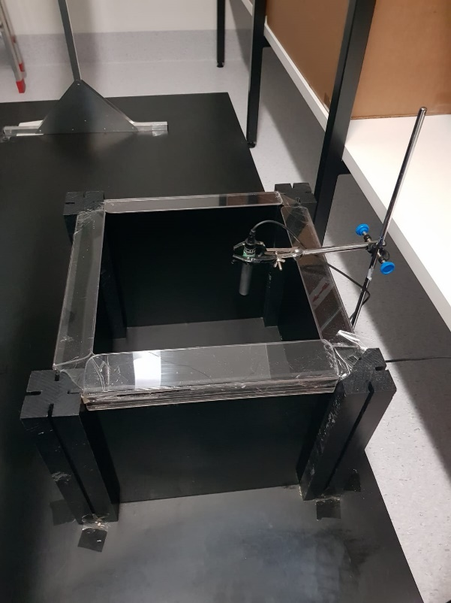
Figure 1. Displaying the anticipation box and microphone used to record USVs.
The Successive Alley:
The successive alley comprises a long, narrow corridor split into four distinct alleys, as exhibited in Figure 2.
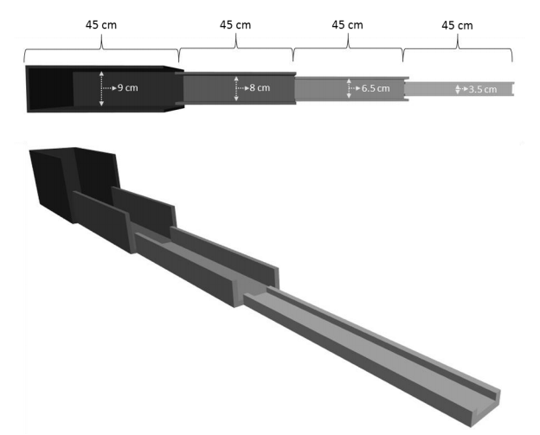
Figure 2. The Successive Alley (Kidwell, 2019)
Each alley is 45cm in length, totalling 180cm. As pictured above, the walls of each alley are shorter than those of the previous, and the floor becomes narrower. Alley one reaches 29cm tall and 9cm in width, alley two is 6cm in height and 8cm wide, alley three is 2.5cm tall and 6.5cm wide, and finally alley four is 1cm tall and 3.5cm wide. Additionally, each alley becomes progressively brighter as the walls become shorter (Alley one averaged 55.33 lux across testing, Alley two averaged 65.55 lux, Alley three averaged 72.8 lux, and Alley four averaged 75.15 lux) This creates a progressively more anxiogenic environment for the animals to explore, removing the ambiguity created by the central area in the EPM, as each alley is assumed to be more anxiogenic than the last, and the animals can only move between then in order of this hierarchy. This also creates a more sensitive measure of anxiety; the EPM has two ‘scary’ arms and two ‘safe’ arms, whereas the SAT contains four levels of anxiety within the alleys. To address the problem of one-trial-tolerance we baited the middle of each alley with one half of a Froot Loop, combining the existing SAT principles with those of the novelty-induced hypophagia test (Cryan & Sweeney, 2011). The rats are trained to consume the Froot Loops during a habituation phase, and are then motivated to enter more anxiogenic areas over repeated testing, negotiating the conflict between the anxiety created by the SAT and the motivation to obtain highly palatable food, which encourages exploration.
Software:
All vocalisations were recorded using Audacity recording software (2021), and were later analysed using Deepsqueak (2019). Ethovision 14XT-Noldus-Virginia was used to track the movement of the animals along the SAT.
Procedure:
Habituation:
Once the animals had completed the intermittent-choice alcohol paradigm, they were left in the home cages for three days before habituation began, to ensure that any residual ethanol was purged from the bloodstream. This insured that any differences found between the drinking and control groups could be attributed to long-lasting effects of ethanol consumption, rather than the immediate effects of intoxication. During this layby period the animals were placed on food restriction with the aim of having them at 90% of their free-feeding weight during the testing phase. This was done to ensure the rats were highly motivated to eat the Froot Loops.
Once the three days had eclipsed, the animals were habituated to the testing room over the course of another three days. The animals’ home cages were brought to the testing room (still housing each animal individually), and the animals were left in their cages to habituate for ten minutes. The room was lit normally (white light), although the overhead lighting had been dimmed to its lowest possible setting (averaged at 32.9 lux across three days of habituation). Once ten minutes had passed, the animals were individually handled for two minutes, and then placed in the anticipation box for a further ten minutes, where rearing and Ultra-Sonic Vocalisations (USVs) were recorded. Following this, the animals were placed back into their home cages and taken back to their housing room. The anticipation box was cleaned using F10SC (a veterinarian sanitiser) between trials to remove the scent of the previous animal(s). To ensure that all animals could be tested/habituated each day, three cages were brought in at once for habituation. All three cages underwent the first ten-minutes of habituation simultaneously, but the animals were handled and placed into the anticipation box independently. Each animal went through the whole habituation procedure in one go, while the other two rats remained in their cages until the previous rat had finished. The order and combination of the cages brought in and tested was counterbalanced. Once the procedure had finished and the cages were moved back into the housing room, each animal was given three Froot Loop halves to ensure that they recognised the cereal as being highly palatable, and were well-habituated to eating them by the time the testing phase began.
Measures:
Anticipation:
To check the efficacy of the Froot Loop reward on the SAT, anticipation was measured across both the habituation and testing period. Higher anticipation in rats is associated with increases in rearing behaviour and in 50-kHz ultrasonic vocalisations (USVs) (Barbano & Cador, 2006). Rearing, broadly defined, is a behaviour wherein the animal lifts its front paws off the floor and stands on its hind legs, and can indicate excitement (Barbano & Cador, 2006). This was further specified to suit the context of the study. A rear was counted as beginning when the animal lifted both paws off the ground, and ending when both paws touched the floor again. Rears were sub-divided into two categories: wall-rears and free-rears. A wall rear was counted when the rat placed at least one of its paws on a vertical wall of the anticipation box. If the animal did not at any point touch a wall during the rear, then it was counted as a free-rear. This division was made following the findings of previous literature, which suggested that the two categories held distinct differences in anticipation from one another. Previous testing within the lab, however, found no differences between the trends of wall-rears and free-rears, so the two were re-combined into one general measure of rearing. We predicted that, as alcohol is both an anxiogenic and a depressant, that the Drinking rats would rear less on average than compared to the control rats, as they would experience less anticipation overall.
Ultrasonic Vocalisations (USVs) were recorded by placing a NOLDUS ultra-vox microphone into the anticipation box, low enough to accurately capture calls, but just out of reach for a rat to jump and grab. Rats are social animals, and call frequently to communicate (Simola, 2015). Rats that show more anticipation should produce more calls indicating excitement than rats lower in anticipation. Subsequently we predicted that the Drinking Rats would produce fewer positive valence calls than the control rats. The majority of rat vocalisations exist in frequencies outside of the human range of hearing (20Hz-20kHz)(Purves et al, 2001), and vocalisations that typically indicate excitement (lovingly nicknamed ‘happy calls’) occur at frequencies approximating 50kHz (Simola, 2015). To ensure that no happy calls were missed all calls between 30-90kHz were counted.
Testing:
The testing phase lasted for a total of six consecutive days and followed immediately from the habituation phase. The animals were brought into the testing room and left in their cages for ten minutes, just as in the habituation trials. Three cages were tested at one time and followed on from the counterbalancing used during the habituation phase. Once ten minutes had elapsed, one animal of the three was removed from their cage and placed into the anticipation box for five minutes, where rearing and USVs were recorded. This was used to measure anticipation; once the rats began to associate being placed in the box with the imminent reward of highly palatable Froot Loops, they should have shown an increase in anticipatory behaviours (USVs and rearing). The higher in anticipation an animal is, the more these behaviours should be observed. Once the five minutes had elapsed, the animals were immediately placed onto the SAT for five minutes. Each alley had been baited with one half of a Froot Loop. The animal was placed on the border between alleys one and two, facing the back wall of alley one. The latency for the rat to eat its first Froot Loop, SAT score, the number of entries to each alley, and overall movement were recorded during this time. After five minutes on the SAT, the rat was picked up and placed back into its home cage. The SAT and anticipation box were then cleaned using F10SC, and the SAT was re-baited with Froot Loops. If there were Froot Loops left uneaten from the previous rat, they were discarded and replaced with fresh ones. This process was repeated for all three animals, and then the cages were moved back into the housing room, where the next group of three were collected for testing.
Anxiety:
SAT Scores:
To measure anxiety in the rats using the Successive Alleys Test (SAT), the number of Froot Loops (out of a total of four) the animal ate per five minute trial, and the alley within which the Froot Loops were eaten, were recorded and calculated to give an overall SAT ‘score’, wherein higher points equates to lower perceived anxiety. The alley in which each of the four possible Froot Loops was eaten was recorded, and each alley where the cereal was eaten was given a value based on its anxiogenic level. Alley one, the least anxiogenic, was worth one point if a rat ate a Froot Loop there. Alley two, more anxiogenic than Alley one, was worth two points for every Froot Loop eaten there. Alley three was worth three points, and Alley four, the most anxiety-inducing, was worth four points per Froot Loop. The number of Froot Loops eaten would be multiplied by the worth of the alleys they were eaten in. This meant that if a rat ate all four Froot Loops, dragging two into alley one to eat and eating the other two in alley two, then their score would be 2 (Froot Loops) x 1 (Alley one’s worth) + 2 (Froot Loops) x 2 (Alley two’s worth). This overall calculation ((2x1)+(2x2)) would give an SAT score of 6 (2+4). A higher SAT score should indicate higher anxiety (the maximum score was 16, which could only occur if a rat ate all four Froot Loops in Alley four). Each rat received a daily SAT score throughout testing. We predicted that the rats would become less anxious with repeated testing and eat the Froot Loops in the more anxiogenic alleys. In theory, only the most anxious rats would not show any increase in their scores over the six days of testing. Consequently, we predicted that the Drinking Rats would have lower SAT scores than the control rats, as they should be less willing to explore and eat the Froot Loops in more anxiogenic alleys.
Movement:
In addition to the SAT scores, we also tracked the total distance moved along the alley per trial, and how many times in total alleys three and four were entered per trial. This measure supplements the SAT score measure of anxiety, as less anxious animals would likely be more active and exploratory along the alley, and so more likely to enter each alley (particularly alleys three and four) more than once. We predicted that the Drinking Rats would move less overall compared to controls, and that they would each enter Alley three and Alley four fewer times than controls.
Latency:
Another supplementary measure of the SAT score was latency to eat the first Froot Loop. Some of the animals may have had low scores on the SAT not because they were extremely anxious, but because they did not eat a Froot Loop until some way into the five minutes on the alley. As a result, we measured latency to act as a support of the SAT score. We would expect that all the animals would take less time to eat a Froot Loop over the course of the six days of testing, as they became more habituated to the SAT and more excited to receive the food reward. We also predicted, in line with our hypothesis that the Drinking rats would be more anxious, that the control animals would show shorter latency overall, as they would likely become more willing to explore sooner than the Drinking rats.

Results:
Drinking:
The twenty Drinking animals consumed an average of 3.60 grams of ethanol per kilogram of body weight across all the drinking sessions (SD = 1.62). This average rose to 4.43g/kg (SD = 1.73) amongst the ten rats that were used in the ADT, who had the highest rates of ethanol consumption of the Drinking animals (exhibited in Figure 3.) Using a repeated measures ANOVA, we found a significant main effect of day upon consumption (F (22, 9) = 9.51, p < .001) for the data of the ten animals later used in the ADT. This indicates that ethanol consumption increased significantly with time.
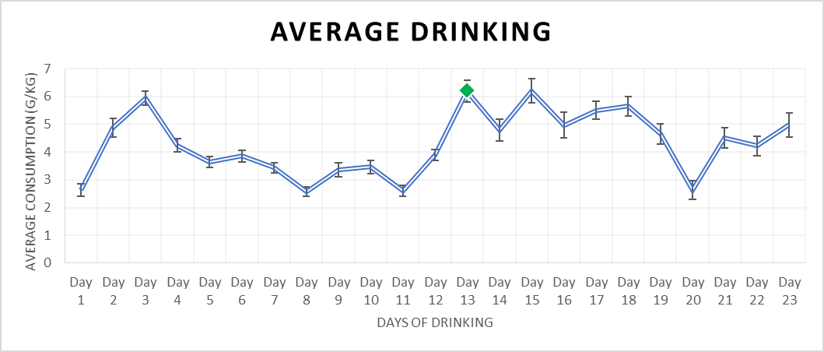
Figure 3. Illustrating the average ethanol consumed (as measured in g/kg) across the 23 days of drinking for the ten rats used in the ADT. The green marker at day 13 indicates the switch from seven hour access to ethanol to 24 hour access.
Habituation:
We used rearing and USVs as measures of habituation. The average number of rears was lower for the Drinking rats (M = 58.43, SD = 19.77) than the controls (M = 60.17, SD = 20.35). Upon analysis using a repeated measures ANOVA, we found a significant main effect of day (F (2, 19) = 29.48, p < .001), seen in Figure 4. This indicates that the rats habituated well to the testing room, as rearing decreased with each day of habituation. There was no significant main effect of condition (F (1, 19) = 0.09, p = .762) nor was there a significant interaction between day and condition (F (2, 19) = 0.55, p = .584).
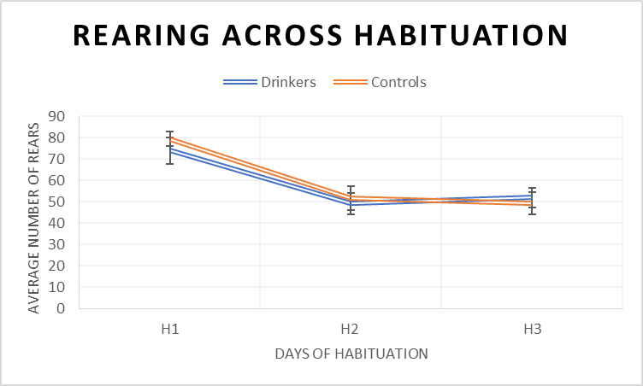
Figure 4. Showing rearing averages across habituation between the two conditions.
The average number of USVs made throughout the habituation phase was higher for the controls (M = 12.79, SD = 49.77) than the Drinking animals (M = 8.04, SD = 24.05). There was no significant main effect of day (F (2, 19) = 1.28, p = .306), nor a significant main effect of condition (F (1, 19) = 0.07, p = .762). There was no significant interaction between day and condition (F (2, 19) = 0.20, p = .820).
Testing Phase:
Anticipation measures:
Rearing:
The average number of rears across the testing phase was marginally higher for the Drinking rats (M = 35.32, SD = 10.48) than the control rats (M = 31.65, SD = 7.78), as shown in Figure 5.
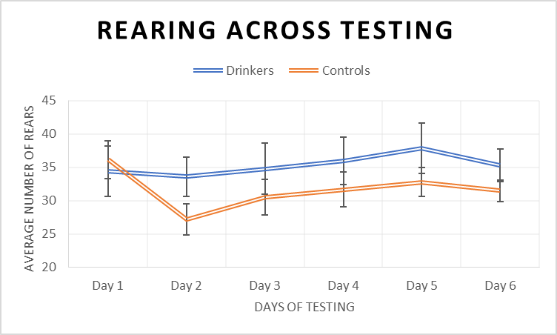
Figure 5. Showing the average rears made by the Drinking Rats and the controls over the six days of testing.
Further analysis using a Repeated Measures ANOVA, we found no main effect of condition upon rearing (F (1, 19) = 1.07, p = .315). This did not support our hypothesis that the Drinking animals would show less rearing than the controls. We found that the effect of day approached significance (F (5, 19) = 2.24, p = .057), indicating that rearing did increase at least marginally, but this is not easily seen in Figure 5.. Finally, there was no significant interaction between day and condition (F (5,19) = 1.37, p = .245).
USVs:
The control animals produced more vocalisations on average (M = 15.76, SD = 41.53) than the Drinking animals did (M = 13.43, SD = 30.61) over the course of testing, although the difference is slight. These averages, however, fail to capture the sheer individual variation between total numbers of calls made. As indicated by the standard deviations above, these averages are not truly representative of the cohort’s vocalisations. In fact, most of the animals made no calls at all, as shown by Figure 6. below:
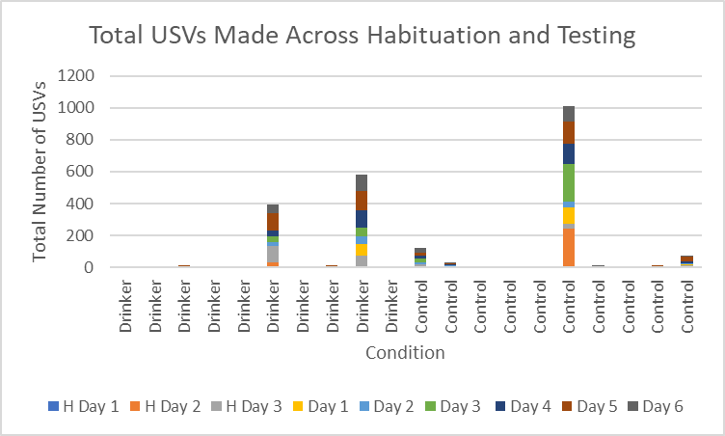
Figure 6. Displaying the total number of calls made by each animal throughout habituation and testing.
As evidenced above, three of the twenty rats contributed the vast majority of the USVs in the dataset, significantly inflating the average number of USVs for both groups. This is supported by the results of the Repeated Measures ANOVA we used to analyse the USV data. There was no significant main effect of day (F (5, 19) = 2.09, p = .074) or condition (F (1, 19) = 0.03, p = .864) and there was no significant interaction between the two (F (5, 19) = 0.87, p = .503).
Anxiety Measures:
Latency to first Froot Loop:
The latency was measured in seconds, with a minimum score of zero (if the animal ate a Froot Loop the moment they were placed on the SAT) and a maximum latency of 300 seconds (five minutes), if the animal did not eat any Froot Loops within the trial. The average latency for Drinking rats (M = 112.50, SD = 116.95) was slightly lower than the controls (M = 153.93, SD = 135.72), shown in Figure 7..
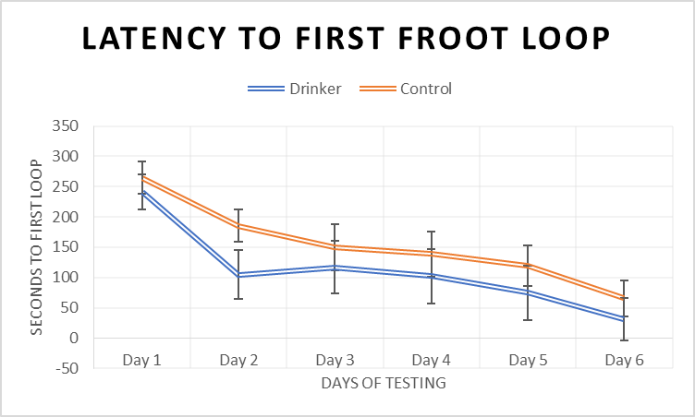
Figure 7. Displaying the average latency of both conditions to the first Froot Loop across the testing phase.
We further analysed these scores using another Repeated Measures ANOVA. There was no significant effect of condition on latency (F (1, 19) = 0.93, p = .348), which did not support our hypothesis that the Drinking animals would show a higher latency than controls. There was, however, a significant main effect of day (F (5, 19) = 19.04, p < .001). This indicates that latency dropped significantly over the course of testing for both groups, which further implies that the animals became more habituated to the alley over this time. There was no significant interaction between day and condition (F (5, 19) = 0.44, p = .823).
SAT Scores:
The average SAT score was higher for drinking animals (M = 4.40, SD = 3.15) than controls (M = 3.20, SD = 3.63). Again, there was wide variation between each condition and within individual animals. As Figure 8. exhibits, most of the rats had very low SAT scores on day one of testing, which gradually rose over the proceeding days.
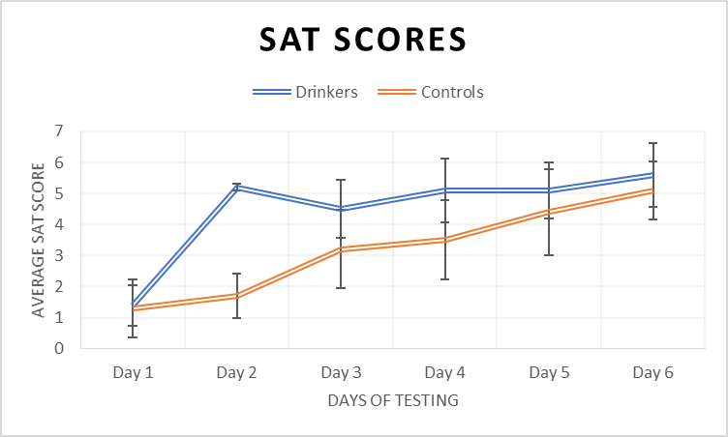
Figure 8. Showing the differences in average SAT scores per day across conditions.
We found a significant main effect of day on SAT scores (F (5,19) = 7.08, p <.001). This result is confirmation that the rats habituated to the SAT over time, and gradually ate more of the Froot Loops overall, and also ate them in more anxiogenic alleys. We did not find a significant effect of condition, however (F (1,19) = 1.19, p = .290). This goes against our prediction that the Drinking rats would have lower SAT scores than the controls, owing to a greater predicted level of anxiety. There was no significant interaction between day and condition (F (5, 19) = 1.35, p = .250).
Entries to Alley Three/Cumulative time spent in Alley Three:
According to average, the Drinking animals entered Alley Three more often (M = 10.72, SD = 3.85) than the controls (M = 8.95, SD = 3.99), and spent slightly more time in seconds in the alley (M = 51.81, SD = 21.13) than the controls did (M = 47.61, SD = 21.89), as shown below in Figures 9. and 10..
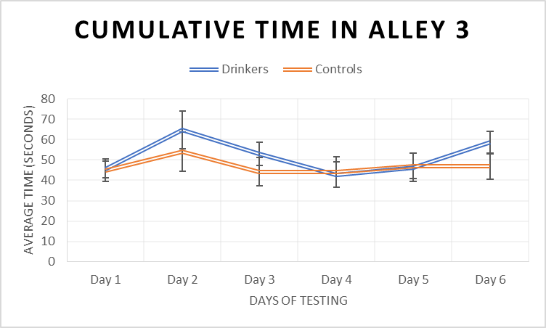
Figure 9. Displaying the average number of seconds spent in Alley Three between conditions.
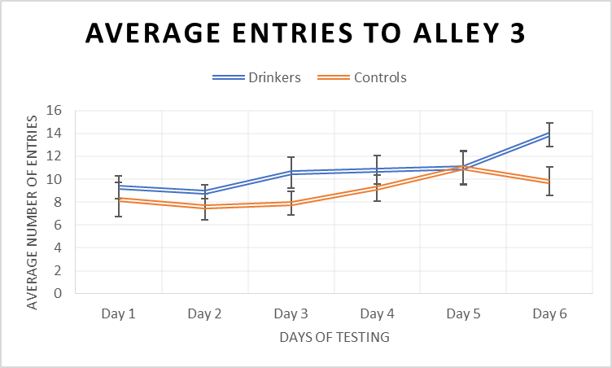
Figure 10. Demonstrating how many times on average Alley Three was entered across conditions.
Upon analysis, neither of these relationships were found to be significant. There was no significant main effect of condition on how many times Alley Three was entered (F (1, 19) = 2.76, p = .114) or how much time they spent there (F (1, 19) = 0.61, p = .446). This does not support our hypothesis that the control animals should spend more time in the anxiogenic alleys than the Drinking Rats. There was no significant main effect of day on the time spent in Alley Three (F (5, 19) = 1.76, p = .129), although we did find a significant main effect of day in the number of times the alley was entered (F (5, 19) = 3.34, p = .008). There was no significant interaction between day and condition in the number of times Alley Three was entered (F (5, 19) = 0.85, p = .518) or how much time was spent there (F (5, 19) = 0.43, p = .827).
Alley Four times entered/Cumulative time spent
The Drinking rats entered Alley Four fewer times on average (M = 4.63, SD = 2.02) than the controls did (M = 5.55, SD = 4.86), and spent less time on average (M = 86.44, SD = 34.04) on the alley than the controls (M = 93.20, SD = 50.34). These relationships are displayed below in Figures 11. and 12.
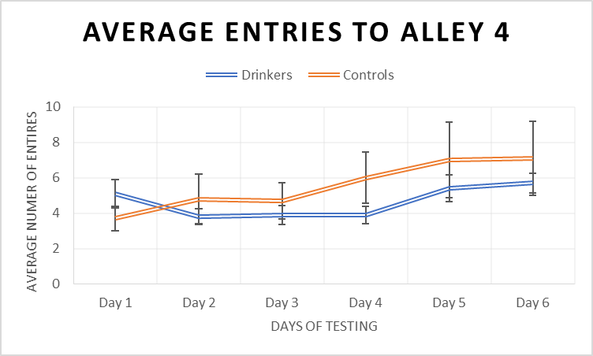
Figure 11. Demonstrating the average number of times each condition entered Alley Four over the days of testing.
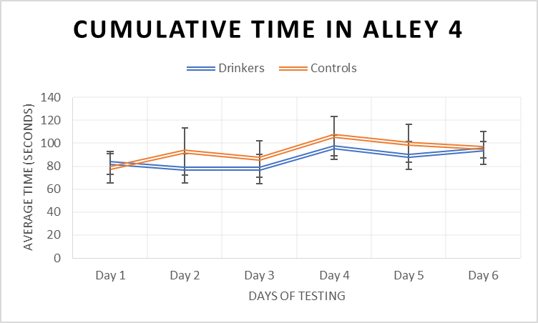
Figure 12. Showing how much time on average each condition spent in Alley Four across testing.
Further analysis using a repeated measures ANOVA revealed that, just as in the analysis for Alley Three, there was no significant main effect of day on cumulative time spent in Alley Four (F (5, 19) = 1.37, p = .244) although there was a significant main effect of day on how often they entered the alley (F (5, 19) = 3.10, p = .012). There was no significant main effect of condition on the number of times Alley Four was entered (F (1, 19) = 0.47, p = .500) or how much time was spent there (F (1, 19) = 0.21, p = .653). This does not support our hypothesis that the control animals should be higher in both of these measures, owing to the Drinking rats being less willing to enter Alley Four at all, due to its more anxiogenic nature. Additionally, we did not find a significant interaction between day and condition for either how often the alley was entered (F (5, 19) = 1.24, p = .298) or how much time was spent there (F (5, 19) = 0.22, p = .944).
Due to technical issues tracking the rats on the SAT, the overall distance moved per trial was cut as a measure, as the subsequent data was misrepresentative and unreliable.

Discussion:
These results paint a very clear picture: there was no effect of drinking on the rats’ anxiety as measured by the ADT. Not one of the measures found a significant effect of condition (upon anticipation or anxiety), and consequently we cannot say that the drinking rats were any more or less anxious than the controls. This was highly inconsistent with our predictions that the Drinking rats would show a greater number of anxious behaviours than the control rats. These results do not replicate the findings of Brocardo et al (2012) and Gilpin et al (2012), who both found that ethanol exposure was associated with an increased anxiety in rats. The results are also inconsistent with previous literature as a whole, which proposes a strong link between alcohol and anxiety.
However, early decisions about how the rats were housed may have heavily influenced the results of this study. The rats were housed individually from weaning for accuracy in ethanol consumption; they did not have social interaction with any other animals beyond this point. In hindsight, this may have been responsible for the possible unreliability in several of the anxiety measures.
Rats are highly social animals, and typically engage in an activity known as ‘play behaviour’ between the ages of 20-35 days old (Vanderschuren et al, 2008). There is evidence to suggest that this period is crucial for cognitive and social development in rats, and isolation during this time can result in severe deficits in both areas (Homberg et al, 2016). It is likely that the animals used in this study were affected this way by being housed individually. We attempted to pair the animals once the drinking period was complete, but severe fighting between several of the pairs prompted immediate separation. Additionally, the rats being housed alone created another issue: boredom. Rats receive a great deal of stimulation from their cage partner, and without one it is almost certain that the animals were starved of such. This was made highly apparent once the rats were placed on the SAT during the testing phase. We expected the animals to be highly timorous and anxious for their first experience of the alley, due to its height, narrow width, and harsh lighting. What we observed, however, was a seeming total lack of fear on the animals’ part. In fact, the animals appeared to be so excited to explore that they completely ignored the Froot Loops placed in each alley in favour of exploring all they could; leaning as far out over the edge as possible and running up and down the SAT. This phenomenon could not be explained by the animals’ drive to explore a novel environment; the rats became bolder by the day. One of the rats developed a habit of jumping off the end of the Fourth Alley onto the experimenter repeatedly on the third day of testing, which continued throughout the experiment and was later copied by other rats. While this was highly entertaining, it paints a worrying picture of the measures used in the ADT.
The rats did not show an increase in anticipation such as we expected, instead remaining at a consistent level throughout testing. We can see in Figure 2. that rearing decreased throughout habituation, which indicates that the effect of the novel Anticipation Box on the animals’ drive to explore faded with time, but did not increase again as it should have, once they had formed an association with the Anticipation Box and SAT. The obvious assumption from these results is that the rats simply did not form this association, or rather, the Froot Loops were not working as an effective motivation to explore the alley. Instead, perhaps being placed on the SAT was exciting enough for these animals. The lack of interest in the Froot Loops, as mentioned above, could explain why we did not see a sharp increase of rearing over the course of testing. However, even if the animals never began associating the Anticipation Box with Froot Loops, we might have still expected to see anticipation rise anyway, if they at least associated the box with imminent placement upon the SAT, which was clearly very exciting for the animals.
The results for the frequency with which the animals entered the third and fourth alleys, compared to the measures of how long they spent there, are similarly vexing. The results initially appear contradictory for both alleys; we found a significant main effect of day on the number of entries to both alleys, but no effect on how long they spent there. We would expect that the rats entering these areas more often would result them spending more time there, but the results do not show this pattern. This seems to indicate that, although the animals became more comfortable entering those more anxiogenic alleys, their visits became increasingly fleeting. Anecdotally, this appears to be true, and the rats did certainly seem to be running up and down the alley with increasing speed throughout the days of testing.
Unfortunately, we cannot use our measure of the total distance moved per trial to confirm this. Due to a suspected calibration or tracking error, the data collected was highly inflated and misrepresentative, even for these over-excited animals. We ultimately chose not to include the results of the measure here, misleading as they were.
There were two dependent variables that were most heavily influenced by the rats’ unusual behaviour. The first was our USVs measure. While the day effect approached significance, and the rats who did produce calls indeed made more over the course of the study (though still insignificantly), the majority of the animals made no calls at all. This all but defeats the purpose of using vocalisations as a measure. This lack of ‘talking’ is highly unusual for rats and does not match other studies that use USVs as a measure of anticipation. Again, we suspect that the choice to house the animals individually during the weeks of alcohol access contributed greatly to this. Rats socialise at a young age, and learn to make calls such as we measured through play behaviour and social interaction (Vanderschuren et al, 2008). It may be that, because this cohort never engaged in these behaviours, the animals were predisposed to silence. Overall, although still statistically insignificant, the rearing measure was perhaps a much more reliable method of measuring anticipation.
The second, and perhaps more worrying, of the two measures to be impacted by our animals’ unusual behaviour was the SAT scores. The SAT scores rely on Froot Loop consumption for accuracy. If an animal eats none of the Froot Loops during the five minute trial, then it is assumed that the rat is highly anxious, and likely too nervous to eat in such an anxiogenic environment. But our animals were far from anxious, rather, they were so excited to be in a new environment that they ran right past the Froot Loops, often not even stopping to smell them. The animals had been placed on food deprivation for three days prior to starting habituation, and this continued throughout testing. When the animals were fed at the end of each day they ate immediately. We had habituated the rats to the Froot Loops over the habituation period, which the rats would eat quickly. This is all to say that there is no explanation for their behaviour on the SAT other than excitement overpowering the efficacy of the food reward. This poses serious problems for the SAT score measure of anxiety. The first few days’ worth of data indicate that the rats were highly anxious, but we know that this was not the case. Indeed, the rats did begin to eat the Froot Loops over the course of testing, perhaps once they had become familiar with the novel environment, but there were several rats that, while clearly displaying no anxiety whatsoever, never once touched the cereal. This created the significant main effect of day on the SAT scores, but is highly misrepresentative of the animals’ actual anxiety. In this, admittedly highly unusual case, the measure is deeply flawed. This should be acknowledged in further studies using the ADT as test of anxiety.
To address these concerns, we aim to replicate this study using paired housing. The animals remaining housed individually between ethanol drinking sessions made for less work for the experimenters during the drinking phase, but almost certainly influenced this study. During the periods where the animals have access to ethanol access must remain individual-only for accuracy in measurement, but there is no methodological reason against the animals being paired outside of those hours. By housing the rats in pairs up until the drinking phase begins, and then keeping the rats in pairs between ethanol access sessions, we can preserve that crucial social learning that the animals in this study missed. This replication is the only viable way to determine whether the housing impacted the behaviour of these animals, and consequently the results of this study, as much as we suspect it did.
Conclusion:
While we failed to confirm our hypothesis that habitual alcohol exposure exacerbates anxiety in rats, we perhaps stumbled upon an interesting effect of housing upon rat behaviour. Having the rats housed individually appears to not only have had a highly unusual effect on the animals’ behaviour, but the behaviour in question highlighted several discrepancies within the Affective Disorders Test. A follow-up study using paired housing makes for a natural next step, and could explain why the animals in this study behaved so peculiarly.

References:
ActionPoint. (2020). Drinking in New Zealand. ActionPoint. https://www.actionpoint.org.nz/drinking-in-new-zealand
Audacity® software is copyright © 1999-2021 Audacity Team. Web site: https://audacityteam.org/ . It is free software distributed under the terms of the GNU General Public License. The name Audacity® is a registered trademark.
Barbano, M., and Cador, M. (2006). Differential regulation of the consummatory, motivational and anticipatory aspects of feeding behavior by dopaminergic and opioidergic drugs. Neuropsychopharmacol 31, 1371–1381. https://doi.org/10.1038/sj.npp.1300908
Babor, T. F., Higgins-Biddle, J. C., Saunders, J. B., & Monteiro, M. G. (2001). Audit. The Alcohol Use Disorders Identification Test (AUDIT): Guidelines for use in primary care.
Barchiesi, R. (2021). Overlapping Neural Substrates of Alcohol- and Anxiety-Related Behavior in the Rat. (PhD dissertation, Linköping University Electronic Press). https://doi.org/10.3384/diss.diva-174707
Brocardo, P. S., Boehme, F., Patten, A., Cox, A., Gil-Mohapel, J., & Christie, B. R. (2012). Anxiety- and depression-like behaviors are accompanied by an increase in oxidative stress in a rat model of fetal alcohol spectrum disorders: Protective effects of voluntary physical exercise. Neuropharmacology, 62(4), 1607-1618. Doi: https://doi.org/10.1016/j.neuropharm.2011.10.006
Chambless, D. L., Cherney, J., Caputo, G. C., & Rheinstein, B. J. G. (1987). Anxiety disorders and alcoholism:: A study with inpatient alcoholics. Journal of Anxiety Disorders, 1 (1), 29-40. Doi: https://doi.org/10.1016/0887-6185(87)90020-X
Coffey, K.R., Marx, R.G. & Neumaier, J.F. (2019). DeepSqueak: a deep learning-based system for detection and analysis of ultrasonic vocalizations. Neuropsychopharmacology. 44, 859–868. https://doi.org/10.1038/s41386-018-0303-6
Cryan, J. F., & Sweeney, F. F. (2011). The age of anxiety: Role of animal models of anxiolytic action in drug discovery. British Journal of Pharmacology. John Wiley and Sons Inc. https://doi.org/10.1111/j.1476-5381.2011.01362.x
Deacon, R. M. J. (2013). The successive alleys test of anxiety in mice and rats. Journal of Visualised Experiments, 76. Doi: 10.3791/2705
Farmer, R. F., Seeley, J. R., Gau, J. M., Klein, D. N., Merikangas, K. R., Kosty, D. B., . . . Lewinsohn, P. M. (2018). Clinical features associated with an increased risk for alcohol use disorders among family members. Psychology of Addictive Behaviors, 32(6), 628-638. Doi: http://dx.doi.org/10.1037/adb0000388
Frye, M. A., and Salloum, I. M. (2006). Bipolar disorder and comorbid alcoholism: Prevalence rate and treatment considerations. Bipolar Disorders, 8 (6), 677-685. Doi: https://doi.org/10.1111/j.1399-5618.2006.00370.x
Gilpin, N. W., Karanikas, C. A., & Richardson, H. N. (2012). Adolescent binge drinking leads to changes in alcohol drinking, anxiety, and amygdalar corticotropin releasing factor cells in adulthood in male rats. PLoS ONE 7(2). Doi: https://doi.org/10.1371/journal.pone.0031466
Homberg, J., Oliver, J., VandenBroeke, M., Youn, J., Ellenbroek, A., Karel, P., ... Ellenbroek, B. A. (2016). The role of the dopamine D1 receptor in social cognition: studies using a novel genetic rat model. The Company of Biologists, 9, 1147 - 1158. doi: 10.1242/dmm.024752.
Karadayian, A. G., Busso, M. J., Feleder, C., & Cutrera, R. A. (2013). Alterations in affective behavior during the time course of alcohol hangover. Behavioural Brain Research, 253, 128-138. Doi: https://doi.org/10.1016/j.bbr.2013.07.011
Keough, M. T., Battista, S. R., O’Connor, R. M., Sherry, S. B., & Stewart, S. H. (2016). Getting the party started — Alone: Solitary predrinking mediates the effect of social anxiety on alcohol-related problems. Addictive Behaviours, 55, 19-24. https://doi.org/10.1016/j.addbeh.2015.12.013
Kidwell, M. (2019). Establishment of an Animal Model of Depression: The Serotonin Transporter Knockout Rat. Victoria University of Wellington, Wellington
Kushner, M. G., Abrams, K., and Borchardt, C. (2000). The relationship between anxiety disorders and alcohol use disorders: A review of major perspectives and findings. Clinical Psychology Review, 20 (2), 149-171. Doi: https://doi.org/10.1016/S0272-7358(99)00027-6
Merikangas, K. R., and Gelernter, C. S. (1990). Comorbidity for alcoholism and depression. Psychiatric Clinics of North America, 13 (4), 613-632. Doi: https://doi.org/10.1016/S0193-953X(18)30339-3
Ministry of Health. (2019). Annual Data Explorer 2017/18: New Zealand Health Survey [Data File]. URL: https://minhealthnz.shinyapps.io/nz-health-survey-2017-18-annual-data-explorer
National Institute of Alcohol Abuse and Alcoholism. (2021). Alcohol’s effects on the body. National Institute of Alcohol Abuse and Alcoholism. https://www.niaaa.nih.gov/alcohols-effects-health/alcohols-effects-body
Pirkola, S. P., Isometsä, E., Suvisaari, J., Aro, H., Joukamaa, M., Poikolainen, K., . . . Lönnqvist, J.,K. (2005). DSM-IV mood-, anxiety- and alcohol use disorders and their comorbidity in the finnish general population: Results from the health 2000 study. Social Psychiatry and Psychiatric Epidemiology, 40(1), 1-10. doi:http://dx.doi.org/10.1007/s00127-005-0848-7
Purves, D., Augustine, G. J., Fitzpatrick D, et al., editors. (2001) Neuroscience. 2nd edition. Sunderland (MA): Sinauer Associates;. The Audible Spectrum. Available from: https://www.ncbi.nlm.nih.gov/books/NBK10924/
Simms, J. A., Steensland, P., Medina, B., Abernathy, K. E., Chandler, L. J., Wise, R., & Bartlett, S. E. (2008). Intermittent Access to 20% Ethanol Induces High Ethanol Consumption in Long-Evans and Wistar Rats. Alcoholism: Clinical and Experimental Research, 32 (10), 1816-1823.
Simola N. (2015). Rat ultrasonic vocalizations and behavioral neuropharmacology: from the screening of drugs to the study of disease. Current neuropharmacology, 13(2), 164–179. https://doi.org/10.2174/1570159x13999150318113800
Spanagel R. (2000). Recent animal models of alcoholism. Alcohol Research & Health : The Journal of the National Institute on Alcohol Abuse and Alcoholism, 24(2), 124–131. PMID: 11199279
Te Hiringa Hauora/Health Promotion Agency. (2021). Effects on the body. Alcohol.org.nz. https://www.alcohol.org.nz/alcohol-its-effects/body-effects/effects-on-the-body
Te Hiringa Hauora/Health Promotion Agency. (2017). Who’s drinking and how much. Wellplace.nz. https://wellplace.nz/facts-and-information/alcohol/drinking-in-new-zealand/
The effects of alcohol on physiological processes and biological development. (2004). Alcohol research & health : the journal of the National Institute on Alcohol Abuse and Alcoholism, 28(3), 125–131.
Vanderschuren, L., Trezza, V., Griffioen-Roose, S. et al. (2008). Methylphenidate disrupts social play behavior in adolescent rats. Neuropsychopharmacol 33, 2946–2956. https://doi.org/10.1038/npp.2008.10
Waka Kotahi/NZ Transport Agency. (2021). Alcohol. Waka Kotahi/NZ Transport Agency. https://nzta.govt.nz/safety/driving-safely/alcohol/

